**PREFACE**

This project report has been developed especially for you computerization and management required in **“STOCK MANAGEMENT SYSTEM”.** It is woven with the fiber of “**MICROSFT VISUAL STUDIO 2010”.** Which is well known standard programming language? All the activities in a program are triggered by one event or another. So, with the help of this software you can do the better computerization of a **“STOCK MANAGEMENT SYSTEM”.**

The aim of preparing this project is to signify the role of computer in smooth functioning of **“STOCK MANAGEMENT SYSTEM”** and to explain that how computers help in records of Admission, record of student’s details and all information related to students of School.

No, doubt I have tried my best effort to make the project in user friendly environment and managing stock management system full placed, because this is the most powerful feature of the project report. The approach adopted is very simple, lucid and comprehensive. The latest term and data have been taken into account and using facility of options and menus.

**Student Name & sign**

**……………………..**

**……………………….**

**TABLE OF CONTENTS**

**S.NO. CONTENTS**

1. Cover page as per format
2. Certificate of the project guide
3. Declaration
4. Introduction
   1. Objective &Scope of the project
   2. Definition of problem

4.3 System Analysis &Design vis-a-vis user requirements

* 1. System planning (PERT Chart)
  2. Methodology adopted,
  3. System Implementation
  4. System maintenance &Evaluation

5 Details of Hardware &Software requirements

6 DFD/Flow Charts

7 Database Structure

8 Screen Design

9 Coding

10 Methodology used for testing.

11 User/ Operational Manual- including security issues.

12 Limitation

13 Bibliography

**2. CERTIFICATE OF THE PROJECT GUIDE**

This is to certify that this project report entitled **“STOCK MANAGEMENT SYSTEM”** submitted **COLLEGE NAME HERE is** a bonafide record of work done by “**STUDENT NAME HERE**” under my supervision.

Date:  **Mr. ASHISH Kr. MISHRA**

Place: ASST.PROFESSOR

**SELF CERTIFICED**

This is to certify that the dissertation /Project report entitled **”STOCK MANAGEMENT SYSTEM”** is done by me is an automatic work carried out for the partially fulfillment of the requirements for the award of the degree of COURSE NAME HERE under the guidance of **Mr. ASHISH Kr. MISHRA.** The matter embodied in this project work has not been submitted earlier for award of any degree or diploma to the best of my knowledge and belief.

Signature of the student Name of the student

………………………… ……………………………

**3. Declaration:-**

This is to declare that this report has been written by me/us. No part of the report is plagiarized from other sources. All information included from other sources have been duly acknowledged. I/We aver that if any part of the report is found to be plagiarized, I/we are shall take full responsibility for it

**Place:** **STUDENT NAME 1**

**Date**- 02/01/2018 Roll no: 13********

**STUDENT NAME 2**

Rollno.13#######

**4. INTRODUCTION**

In today’s changing life style computer has become the most essential part of life. Most of the works being performed by the humans is now done by the computer The computer is being used in each and every field now a days.

 I am developing software for a stock exchange and  This software help in the stock exchange for their database maintaining and generating report corresponding to the data is done on the basis of as per requirement is given.

So, we can say that it helps the management of stock exchange and give exact database management of company according to rules and regulation. It also help in maintain stock data and also display how many products are present in the stock and also gives the details of these products . This software also gives or stores each and every information about orders.

This company uses a huge data base so for security of database we give the facility of backup and also recovery as per when company need it takes backup on floppy or on hard disk.

This project is targeted for the mass stock management system around our country of further. Stock management is a very complex process which also needs a very efficient management. It enhances correctness and reduces man power. It also gives a detail and variety of angel for producing different types of report.

**4.1 Objective & Scope of the project:-**

**Primary objective**

1. The primary objectives of the project are mentioned below:
2. To fulfill the requirement for achieving the Bachelor’s degree of Computer Information System.

1. To know the fundamentals of the .Net Technology and Visual Studio with the.Net Framework

**Secondary objective**

1. The secondary objectives of this project are mentioned below:

1. To develop an application that deals with the day to day requirement of any production organization.
2. To develop the easy management of the inventory

1. To handle the inventory details like sales details, purchase details and balance stock details.

1. To provide competitive advantage to the organization.

1. To provide details information about the stock balance.

1. To make the stock manageable and simplify the use of inventory in the organization.

**Project Scope:-**

This is a type of software, suitable to all shope. This software have all the modules to manage stock & inventory transactions. Separate division is provided to maintain product details.

Initial functional requirements will be: -

* Secure registration and profile management facilities for all modules

This project can be used within intranet or over internet.

Stock Management System (SMS) is targeted to the small or medium organization

which doesn’t have many warehouses i.e. only to those organization that has single power of authority.

Some of the scope are:

Only one person is responsible in assigning the details or records

 It is security driven.

**4.2 Definition of problem:-**

  It is too hard to maintain the record about the daily intake of the raw material and view in the detail as a whole. The improvement in the production cannot be viewed easily when done manually. A record about the production when once created is too hard to delete.

  This is mainly designed for the manufacturing companies. It improves its business by facility of maintaining the record. Its password setting of the administrator helps to improve security. It helps the user to view the details of the stock of various categories and the sales of their requirement.

**Module wise description**

1. Dealer
2. Product
3. Customer
4. Payment
5. Category

4.4 Methodology adopted:-

This model is development combines the features of the prototyping model and the waterfall model. The spiral model is intended for large, expensive and complicated projects.

The steps in the spiral model can be generated as follows:

* The new system requirements are defined in as much detail as possible. This usually involves interviewing a number of users representing all the external or internal users and other aspects of the existing system.
* A preliminary design is created for the new system.
* A first prototype of the new system is constructed from the preliminary design. I.e. usually a scaled-down system, and represent an approximation of the characteristics of the final products.
* A second prototype is evolved by the fourfold procedure:
* Evaluating the first prototype in terms of its strengths, weakness and risks
* Defining the requirements of the second prototype.
* Planning and designing the second prototype.
* Constructing and testing the second prototype.

The team of the project follows a methodology as to which the project would be initiated. The methodology adopted carries various approaches to be used in the project. Data flow Diagram, charts, flow charts are used to show the concept of the project.

**The various methodologies adopted are:-**

1. Data flow diagram: Data flow diagram is used to depict the transaction of the data, processing of the data and flow of data. It also shows the relationship between entities.
2. Charts: Chart represents the picture of the project structure which includes organization and system structure.

Flow chart: Flow chart is the pictorial representation of the complete flow of the project. It shows the sequence and the direction of the project

**4.5 System Implementation:-**

The system implementation is very effective of the project to the system requirement data. It is a system requirement implementation of the system analysis. System requirement of the data to the system maintenance and data recovery

After getting our project coding complete we have to get the project Implemented on system for use, therefore to implement our project following should be done:

* MS_SQL Server 2008 should be installed with appropriate Database.

Operation implied by a message that is passed to an object. Implementation details include information about the object’s private part; that is, internal details about the data structure that describe the object’s attributes and procedural details that describe operations.

An Implementation description that shows implementation details for each

The protocol description is nothing more than a set of message and a corresponding comment for each message.

For example, a portion of the protocol description for the object of Database.

5. **Details of Hardware &Software requirements:-**

**System Requirement:**

1. **Hardware Specification:-**

It is recommended that the minimum configuration for clients is as appended below:-

Suggested Configuration of Windows clients:-

Microprocessor : Pentium-4 class processor, 2.2 GHz

Ram : 1GB of RAM.

Hard Disk : 10 gigabytes (GB) on installation drive, which includes 500 MB on system drive.

CD ROM Drive : 52 X CD ROM Drive.

1. **Software Specifications:-**

Operating System : Windows 8.

RDBMS : SQL Server 2008.

Front End : Microsoft Visual Studio 2010.

.

This system was developed under window 8. It is complete with all 64-bit versions of windows operating system. Windows is a popular and largest used operating system in the world because it is easy to understand and provides an easy interface to users.

1. **Windows 8:**

The main responsibility of an operating system is to manage computer’s resources. All activities in the system scheduling application programs, waiting files to disk, sending data across a network and so on should function as seamlessly and transparently as possible. Windows8 makes your computer easier to use, with new and enhanced feature.

**Faster Operating System:**

Windows 98 includes tools that help your computer run faster than Windows 95 without adding new hardware. Window 98 includes a suite of programs designed to optimized you’re web.

**Integration:**

Windows 98 Explorer and Internet Explorer integrate local and Web-based resources in a single viewer computer’s efficiency, especially when used together. Window 98 makes your computer more entertaining by new hardware. These enhancements provide you with hours of fun.

**Multitasking Concepts:**

Multitasking in general refers to an operating system’s capability to load and execute several applications concurrently. A multitasking operating system is consider a robust and reliable one if it successful shields concurrent applications from each other, making them believe that they system also shields application from other’s bugs.

To large extent, multitasking operating system relay on system hardware to implement these capabilities. Another important aspect of multitasking is process scheduling. As process is capable of executing only a single stream of instruction at any given, multitasking would obviously not be possible without the technique of the context switching. A context switch, triggered by a specific event (such as an interrupt from a timer circuit or a call by the running application to a specific function), essentially consist of saving the processor context (instruction pointer, stack pointer, register contents) of one running program and loading that of another.

In a cooperative multitasking environment, the operating system relies explicitly on applications to yield control by regularly calling a specific set of operating system functions. Context switching takes place at well-defined point during the execution of a program.

**7 . DFD/Flow Charts:-**

The Data flow Diagram shows the flow of data. It is generally made of symbols given below:

A square shows the Entity.

A Circle shows the Process

An open Ended Rectangle shows the data store.

An arrow shows the data flow.

The DFD can be up to several levels. The 0 level DFD states the flow of data in the system as seen from the outward in each module.

The first level DFD show more detail, about the single process of the 0 level DFD

The second level DFD can show even more details and so on.

**Construction a DFD:**

1. Process should be named.
2. The direction of flow is from top to bottom and from left to right.
3. When a process is exploded into lower level details, they are numbered.
4. The name of data stores, sources , and destinations are written in capital letters. Process and data flow names have the first letter of each word capitalized.

**8 Feasibility Analysis**

This software has been tested for various feasibility criterions from various point ofviews.

**1 Economic Feasibility**

The system is estimated to be economically affordable. The system is medium scaledesktop application and has affordable price. The benefits include increasedefficiency, effectiveness, and the better performance. Comparing the cost and benefitsthe system is found to be economically feasible.

**2 Technical Feasibility**

Development of the system requires tools like:

Visual Studio 2015 .NET Framework 4.5

Microsoft SQL server 2008, etcWhich are easily available within the estimated cost and schedule

**Input To The Project**: Stock Management System project

There is Many Input From in this project:

**1.    Home**

**2.    Add Dealer**

This Form is Used For Entering Complete Dealer information.

**3.    Customer Form**

This Form is Used For Entering Complete Customer information.

**4.    Product From**

This Form is Used For Entering Complete Product information.

**5.    Order Form**

This Form is Used For Entering Complete Order information.

**6.    Order Detail Form**

This Form is Used For Choosing  Products For Order from products List.

**7.    Receiving Amount Form**

This Form is Used For Entering  information About the amount Received By Customer .

**8.    Remain Amount Form**

This Form is Used For Entering  information About the amount Remain On a Customer .

**9. Update Form**

This Form is Used for  updating information of Database.

**9- SCREEN SHOT**

Home.aspx:

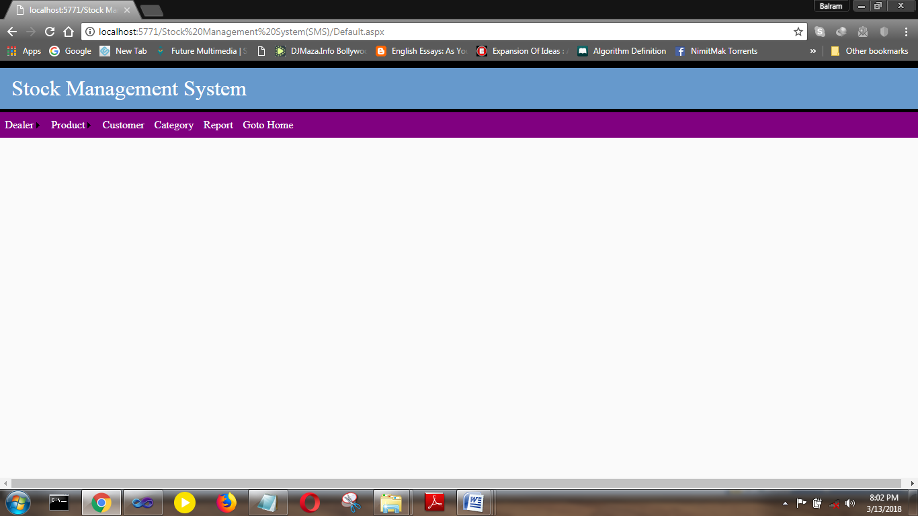

Add Dealer.aspx:

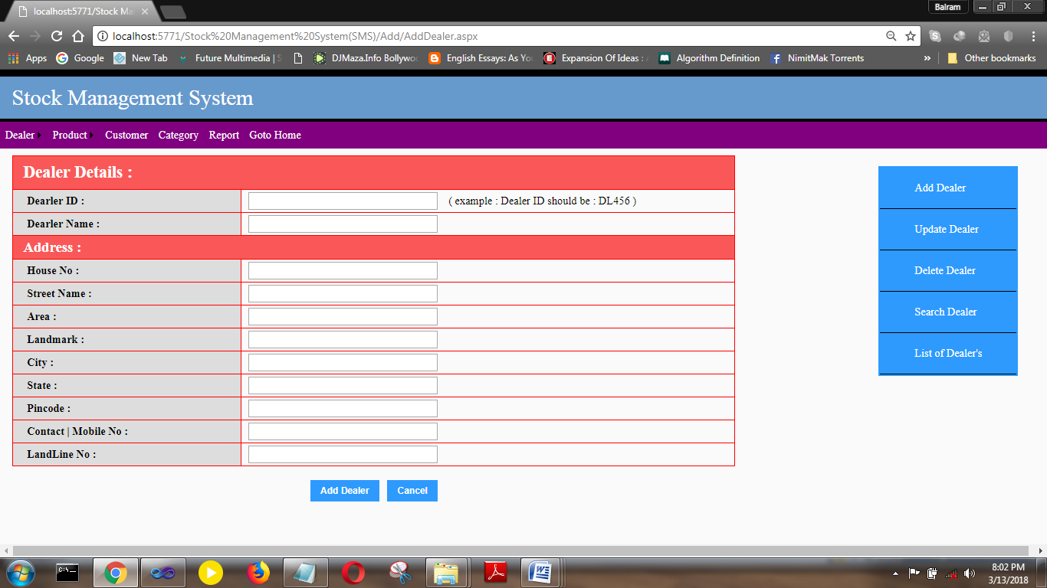

Update Dealer

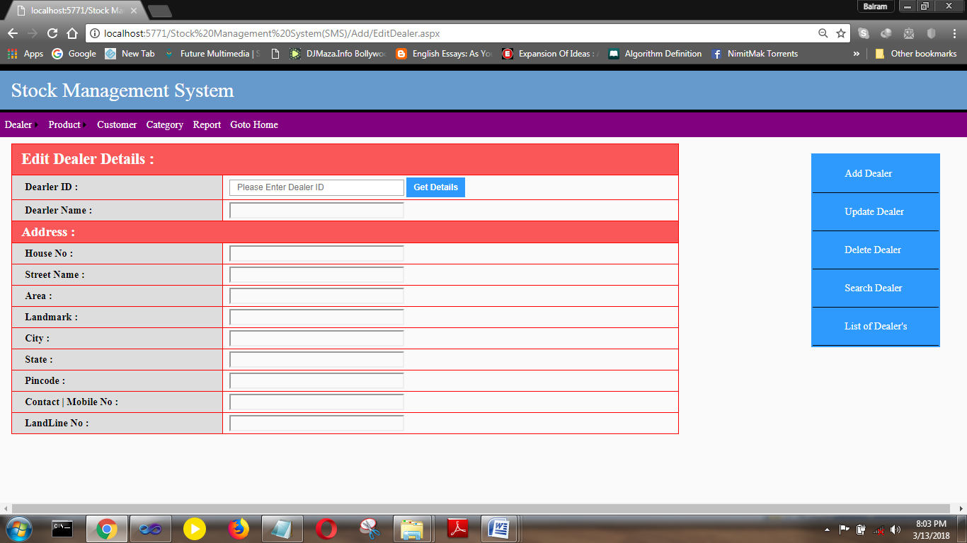

Delete Dealer:

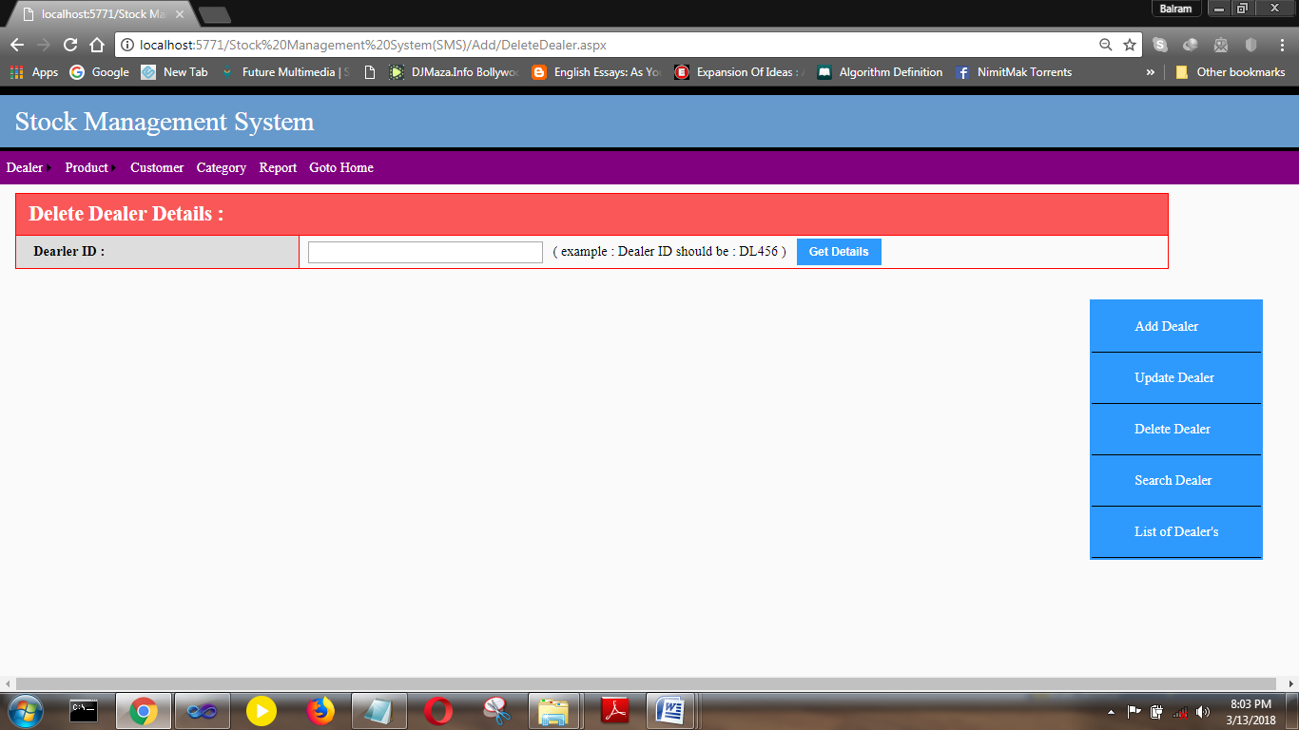

List of Dealer:

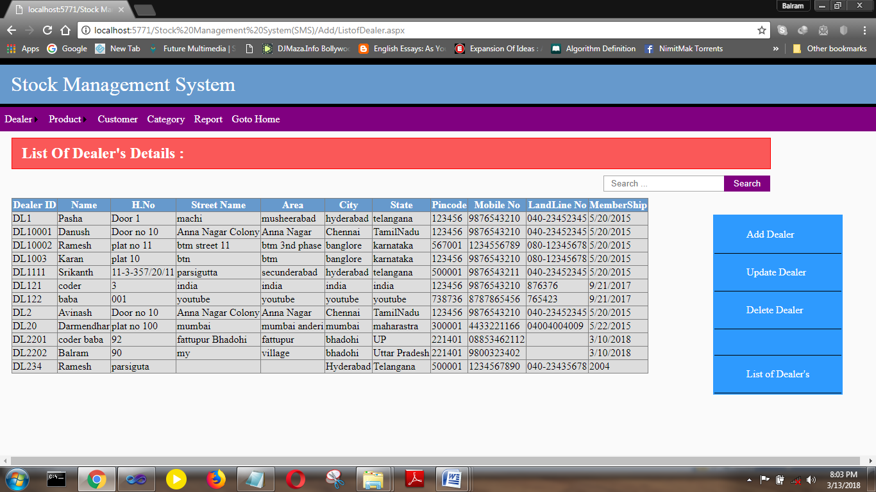

Add Product:

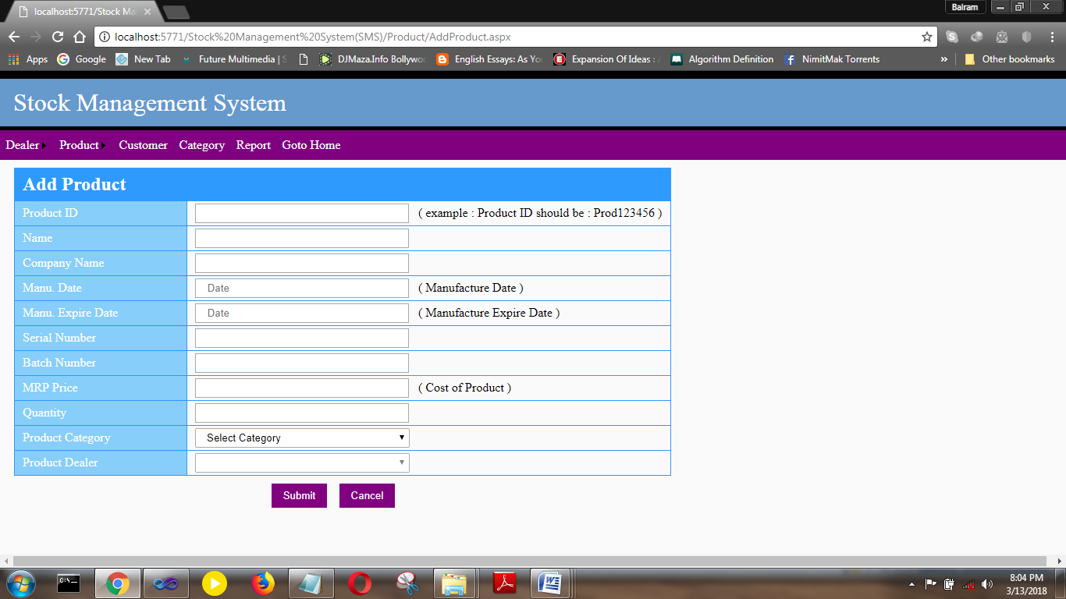

Edit Product:

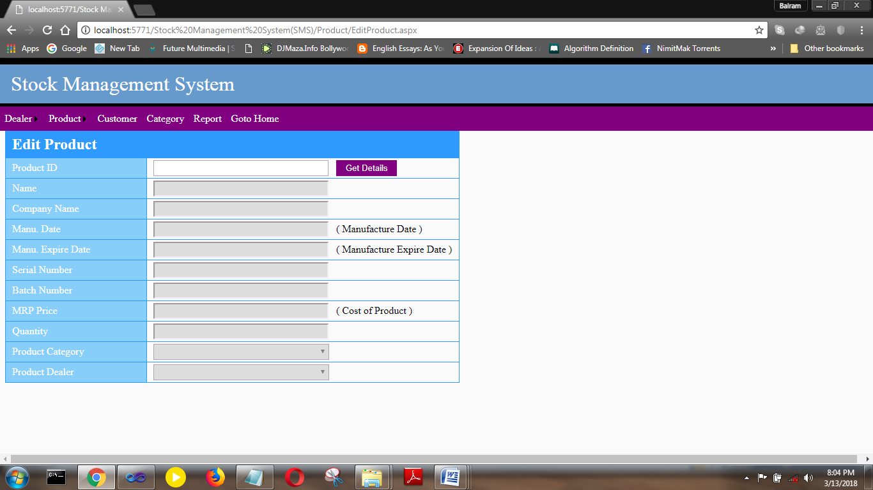

Customer Details:

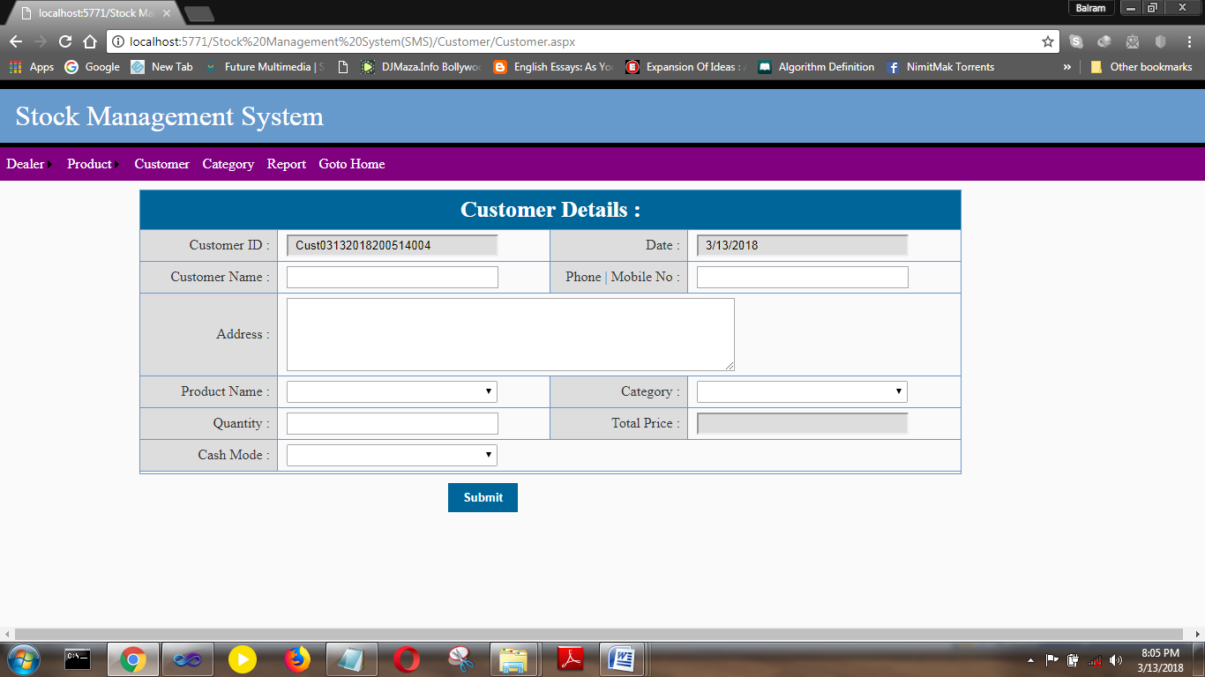

Category:

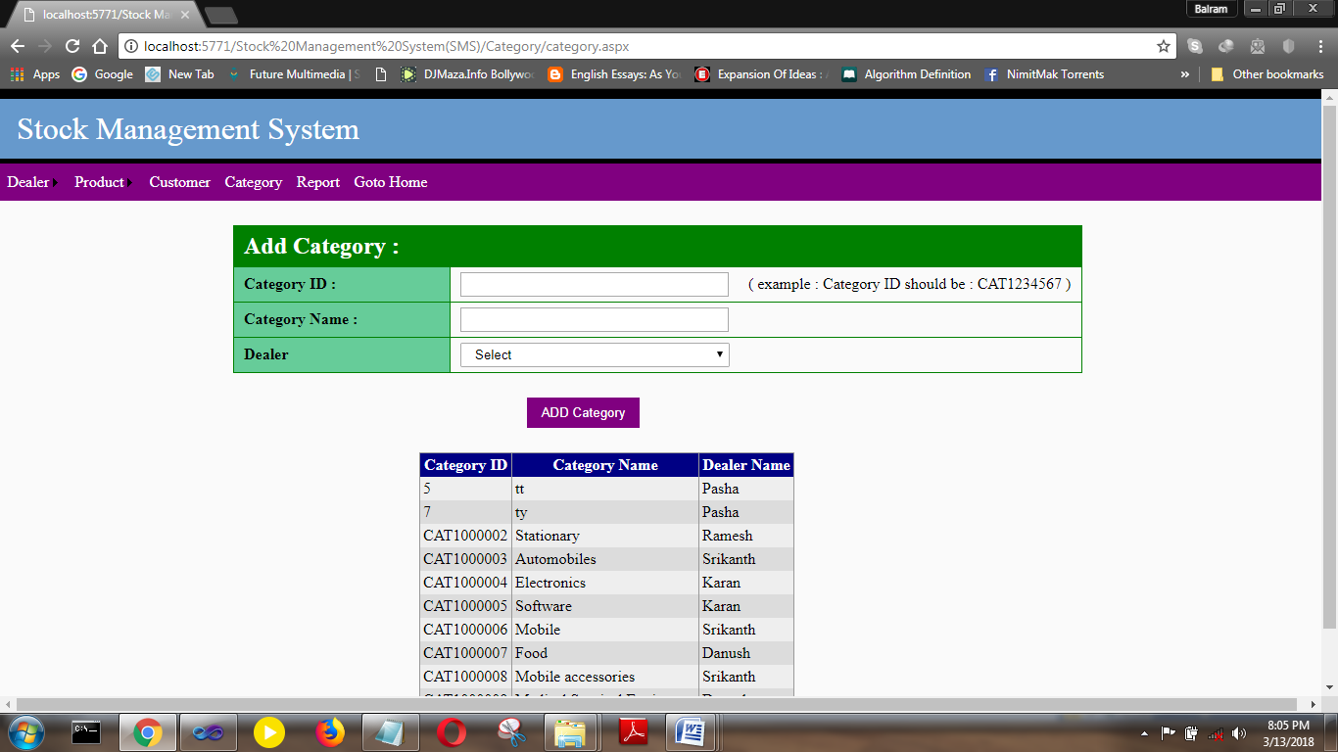

Report:

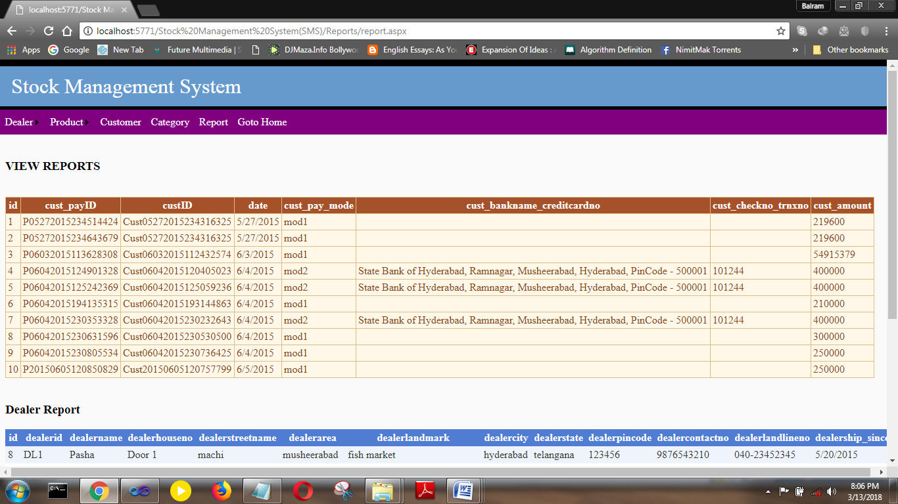

**Existing system:**

People tend to make errors like data entry and others.

Manual entry is also huge time consuming.

Reports are not attractive.

**Proposed system:**

Simplicity in controlling system.

Leaving all manual control totally.

Security and quality management.

Reducing human errors.

Attractive report generator.

**10. Methodology used for testing:-**

**Unit Testing:-**

Unit testing emphasizes the verification effort on the smallest unit of software design i.e. a software component or module. Unit Testing is a dynamic method for verification, where program is actually compiled and executed. Unit testing is performed in parallel with the coding phase. Unit testing tests units or module not the whole software.

**White Box Testing:-**

White box testing strategy deals with the internal logic and structure of the code. White box testing is also called as glass, structural, open box or clears box testing. The tests written based on the white box testing strategy incorporate coverage of the code written, branches, paths, statements and internal logic of the code etc.

In order to implement white box testing, the tester has to deal with the code and hence is needed to possess knowledge of coding and logic i.e. internal working of the code. White box test also needs the tester to look into the code and find out which unit/statement/chunk of the code is malfunctioning.

**Black Box Testing:-**

Black Box Testing is not a type of testing; it instead is a testing strategy, which does not need any knowledge of internal design or code etc. As the name "black box" suggests, no knowledge of internal logic or code structure is required. The types of testing under this strategy are totally based/focused on the testing for requirements and functionality of the work product/software application. Black box testing is sometimes also called as "Opaque Testing", "Functional/Behavioral Testing" and "Closed Box Testing".

The base of the Black box testing strategy lies in the selection of appropriate data as per functionality and testing it against the functional specifications in order to check for normal and abnormal behavior of the system. Now a days, it is becoming common to route the Testing work to a third party as the developer of the system knows too much of the internal logic and coding of the system, which makes it unfit to test the application by the developer.

**11. SECURITY ISSUES:-**

* In the Stock Management process various security issues have been implemented. Like The student/Administrator can’t enter in the system without a valid login name and password.
* This project can be upgraded in future and many more advanced features can be added to it.

**Access rights:-**

* Only Administrator able to access Database.
* Student can only access Main menu. He/she can not access Admin rights

**12. Limitation**

1. This project does not cancel the student details once placed, due to using third party tool (Web Services) expect Admin.

2. Student/Parent cannot change the details after submitting the Registration form.

3. Registration duplication is strictly prohibited.

4. Parents can not see his child details without Login.

5. This application have access any database.

6. This application does not have any PDF file downloading with user administrator requirement

**Conclusion:**

The system is designed to reduce human labor and efficiently maintaining the stock.

It provides flexible and powerful reports regarding items purchase sales and ledger.

We hope that it will help people to reduce both time and money.

**Stock Management** Software Systemis offering a maximum of stability, cost-effectiveness and usability. **It provides** the most flexible and adaptable standards management system software solutions for shop.

**Future enhancement:**

There is always room for improvement in any software system

1. determining the frequency for ordering and forecasting accordingly.
2. Generating the demand priority report of items in different cities.
3. Automatic email notification when any specific item is about to stock out.

**13.Bibliography:-**

1. Beginning Visual Basic 2010 programming

2. Beginning ASP.NET 3.5 in

3. Mastering in VB.NET (Black Book)

4. Mastering in ASP.NET 3.5 (Stephan feather)

5. [www.google.com](http://www.google.com)